UNIVERSITY OF TORONTO

Department of Nutritional Sciences

Mid-Term Examination 2014

November 6, 2014

Advanced Nutrition
NFS 484H1 F/ 1484H1 F

Duration – 2 hours

General Instructions
- This is an open book examination; therefore students may use any aids that have been brought into the examination room. However, electronic devices may only be used to scroll through class notes. Texting and internet access is not permitted.
- The examination is divided into 2 parts (2 studies) worth 17 marks and 33 marks respectively, for a total of 50 marks. The midterm examination will comprise 30% of your final grade.
- Students must answer all questions in all parts of the examination. Please be certain to allocate your time appropriately to ensure that you are able to complete all parts of the examination.
- All answers should be clearly provided in the answer booklets provided. Please provide your answer on the right-hand side of the page only. It will be assumed that the left-hand side of the page is used for note making purposes only and material appearing on this side of the page will not be read or graded.
- PLEASE DO NOT WRITE IN PENCIL. Feel free to cross out anything that you want. Pencil smears and is often difficult to read. Thanks for your consideration in this request.
Background Information
Vitamin D is a fat-soluble vitamin stored in adipose tissue. Food sources include fortified milk and cereals, as well as the flesh of fatty fish such as sardines, salmon, and tuna. Vitamin D is also produced by the body when the skin is exposed to the sun’s UV rays. There is evidence that has implicated Vitamin D in the prevention and alleviation of diabetes risk factors. In particular, Vitamin D supplementation may play a role in chronic inflammation, glycemic control, and insulin resistance; however, no clear mechanism has been described.
Type 2 Diabetes Mellitus (T2DM) is characterized by prevailing insulin resistance (IR), which causes increased levels of circulating insulin and blood glucose. Previous research has demonstrated vitamin D deficiency in people living with T2DM. In Canada, Inuit and First Nations women who are living in northern Canada are at a high risk for developing T2DM and have been shown to have a higher prevalence of vitamin D deficiency due to their limited sunlight exposure. The vitamin D receptor (VDR) gene encodes the nuclear receptor protein for vitamin D3. Decreased expression of VDR may lead to decreased transcription of vitamin D related genes. The underlying mechanism(s) responsible for vitamin D’s role in the prevention and alleviation of diabetes risk factors is not fully understood and appears complex.

Study 1
A randomized, controlled, double-blinded intervention was performed to investigate the effect of vitamin D supplementation on insulin resistance in 235 First Nations women living in Canada’s Northwest Territories. All participants were insulin resistant (IR >1.93) and vitamin D deficient (serum 25-hydroxyvitamin D [25(OH)D] concentration <50 nmol/l). 4000 IU of vitamin D3 (Cholecalciferol – the form of vitamin D made in the skin; it is then converted to 25(OH)D in liver and then its biologically active form, 1,25(OH)D, in the kidney. For the purpose of this examination, you can assume that the conversion of Vit D3 to its biologically active form is unimpeded) or placebo was administered daily for 6 months. 25(OH)D, fasting serum glucose and insulin, insulin resistance (IR), and pancreatic beta-cell function(BCF instead?) were estimated, using validated methodology, at the beginning and end of the 6-month trial. Higher beta-–cell (function?), and IR values indicate improved beta-cell function and increased insulin resistance, respectively.
Questions:
1. Describe the results from Table 1. (3/50 marks)

2. Based on the study results, background information and your general knowledge of diabetes risk factors, propose a mechanism by which vitamin D status affects risk of type 2 diabetes. Be certain to include all variables presented in the table in your answer. (8/50 marks)

3. If both groups were given an oral glucose load at the end of the 6-month intervention, how might the response to the load differ between the vitamin D supplemented group and placebo group? {You are welcome to draw a figure and explain it in words if this is the best way for you to develop your answer.} (6/50 marks)

Table 1. Changes from baseline to endpoint of primary outcomes within vitamin D and placebo groups, and between groups
 | Vitamin D (n=42) |  | Placebo (n=39)
 | Mean | P value –within group difference | Mean | P value –within group difference | P value –between group difference
25(OH)D (nmol/l)
Change (end-baseline) | 49 | <0.001 | 8 | <0.001 | <0.001
Beta-cell function (Beta)
Change (end-baseline) | -11.2 | 0.17 | 5 | 0.27 | 0.25
Insulin Resistance (IR)
Change (end-baseline) | -0.2 | 0.03 | 0.2 | 0.27 | 0.02
Fasting Insulin (mU/l)
Change (end-baseline) | -1.3 | 0.02 | 1.1 | 0.07 | 0.02
Fasting Glucose (mmol/l)
Change (end-baseline) | 0.1 | 0.154 | 0.1 | 0.12 | 0.82

There were no significant differences in any of the variables between the vitamin D supplemented and placebo groups at baseline. P values in columns 3 and 5 are for the change within each group from baseline to endpoint. Column 6 is the P value of the difference between groups in the change for each variable (i.e. one group experienced a greater change over time than the other group).
Study 2
T2DM may involve an alteration in the expression of glucose transporters, such as GLUT4, which may have an impact on the uptake of glucose by the cells. The present study was designed to investigate the effect of Vitamin D in the overall regulation of muscle cell GLUT4 mRNA expression.
At 6 weeks of age, mice were divided into 3 groups. Group 1 (Control) was fed a standard chow diet; Group 2 (IR) was fed a high fat-high sucrose (HFHS) diet, known to produce insulin resistance (IR) in mice and Group 3 (IR+D) was fed the HFHS diet supplemented with high dose vitamin D3 (providing 800 IU per day) for 3 weeks.3 Mice were then sacrificed and muscle biopsies were taken. Subsequently, mRNA for the vitamin D receptor (VDR), GLUT-4, and insulin receptor were measured

Questions:
5. Describe the results from Figure 1. (3/50 marks)
6. In no more than one to two sentences, state the primary outcome(s) of this study. Keep your answer concise, this question is to help you focus on the primary results to develop your interpretation in later questions. (4/50 marks)

7. Using the information presented in both studies, propose a mechanism by which vitamin D supplementation influences glycemic control. (8/50 marks)

8. During the last several decades, First Nations populations living in Canada’s Northwest Territories have moved away from their traditional diet (high in lean protein, fatty fish, and complex carbohydrates) and adopted more ‘Western style’ diets (high in high-fat protein and high glycemic index carbohydrate foods and low in fatty fish). Drawing on all the data presented in this examination, discuss the impact of this dietary change on T2DM risk in the context of low sunlight exposure and poor vitamin D status. (8/50 marks)

9. A reasonably large proportion of First Nations individuals living in the Northwest Territories have a single nucleotide polymorphism at amino acid 319 (G→S) in the HNF1A gene which causes a decrease in pancreatic beta-cell insulin production. Discuss the potential effect of vitamin D supplementation on individuals who are either homozygous (HZ) for the SNP or wild type (WT; not carrying the SNP) for the HNF1A gene and what effect this would have on T2DM risk. Make sure to compare and contrast the impact of vitamin D supplementation in both the HZ and WT groups (you do not need to consider the heterozygote group in your answer). (10/50 marks)

EMBED SPW 11.0 Graph5 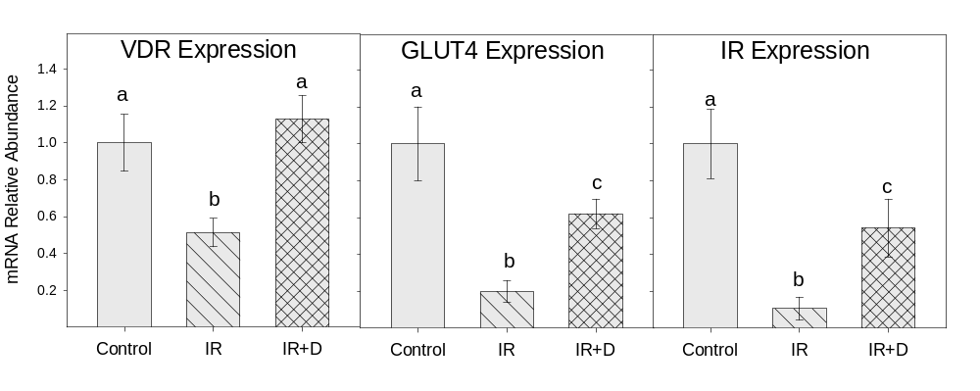
Figure 1. Vitamin D receptor (VDR), GLUT-4 and insulin receptor mRNA expression (Control = normal chow diet; IR = high fat-high sucrose diet to produce insulin resistance; IR+D = high fat-high sucrose diet supplemented with high dose vitamin D3. Histograms (bars) with different letters, within each measure, indicate that the variables are significantly different from each other (p<0.05).

